39.Design DFA using simulator to accept the string the end with abc over set {a,b,c)

W= abbaababc

INPUT:

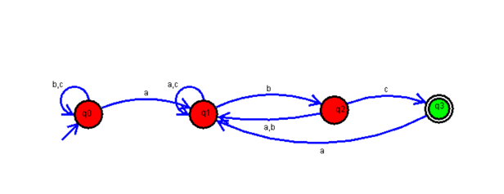

OUTPUT:

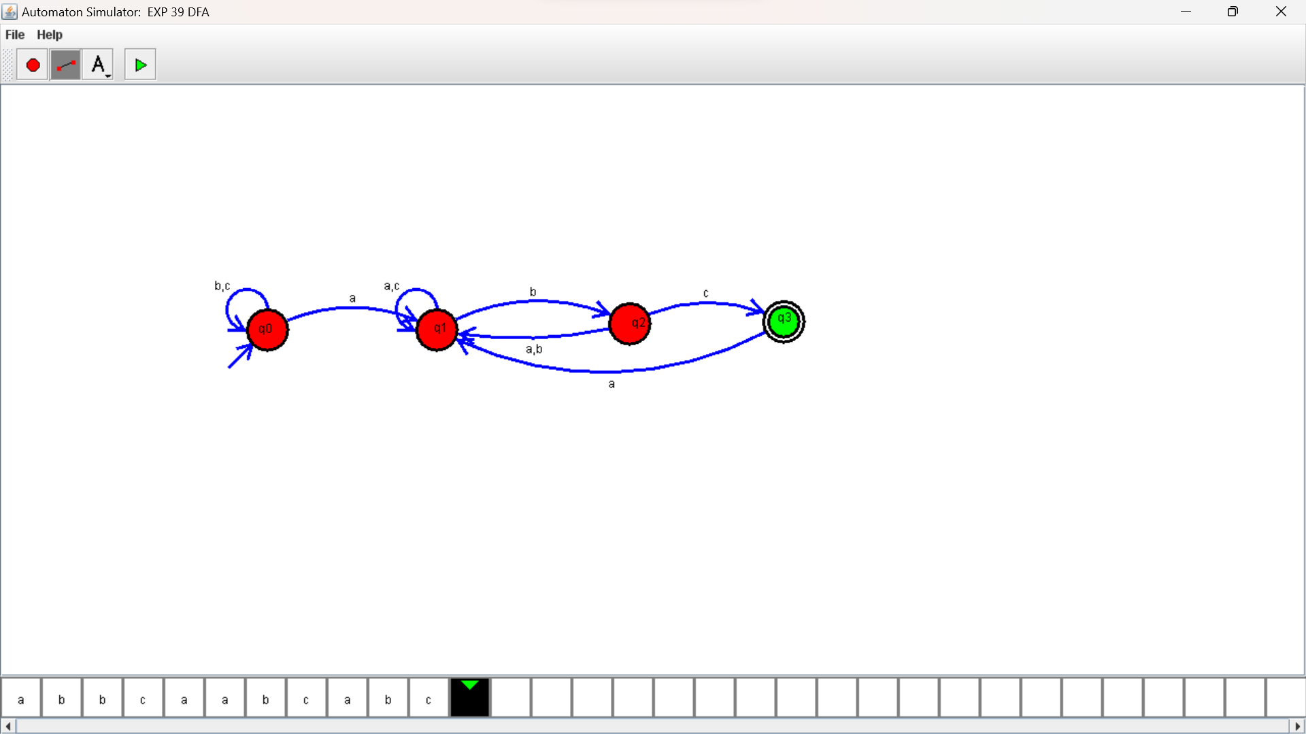

RESULTS:

DFA using simulator to accept the string the end with abc over set {a,b,c)

W= abbaababc